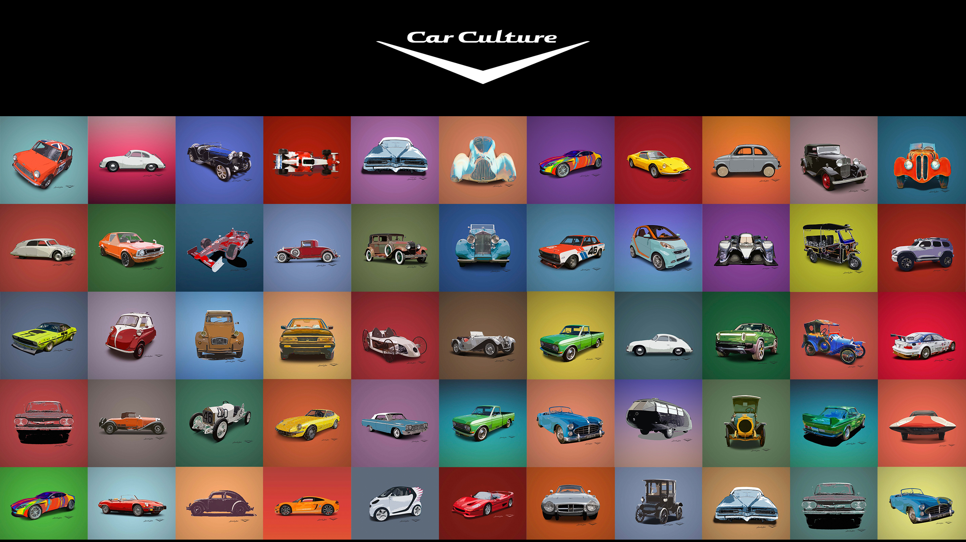

# Automobilia II, LLC

**Patent-Powered AI Technology: Transforming Toy Car Heritage & Engagement**

INNOVATION & VALUE PROPOSITION

• Patent NOA in AI technology that brings toy cars to life through verified historical data

• Enables children and collectors to create and preserve their own toy car stories

• Protects Mattel's IP while enhancing brand engagement

• Creates new revenue streams through authenticated content and experiences

• Preserves global automotive heritage through authenticated knowledge base

TECHNICAL EXCELLENCE

• Multi-modal neural architecture designed for toy car identification and storytelling

• Processes images, video, text, and user-generated content with verified accuracy

• Supports both real-time and historical toy car identification

• Enables secure data sharing while maintaining IP protection

• Global coverage of automotive heritage and documentation

PROVEN DATASET

• Copyright-protected database of thousands of verified automotive assets

• Comprehensive coverage from 1885 to present

• Includes images, videos, technical specifications, and historical documentation

• All assets authenticated through Library of Congress registration

• Global representation of automotive heritage

### MATTEL APPLICATIONS

Hot Wheels & Matchbox

• Authenticate limited edition releases

• Verify collector's items

• Create digital certificates of authenticity

• Enable collector-to-collector trading with verified history

• Connect to global automotive heritage

Digital Engagement

• Allow children to record their toy car adventures

• Create family memories around toy car collections

• Enable sharing of verified toy car stories

• Build intergenerational connections through toy car history

• Preserve family automotive heritage

Collector Community

• Verify rare and limited edition items

• Create authenticated collector profiles

• Enable secure trading of verified items

• Build trust in the collector marketplace

• Connect to global collector networks

Brand Enhancement

• Connect toy cars to their real-world counterparts

• Provide educational content about automotive history

• Create immersive experiences around toy car collections

• Build brand loyalty through verified content

• Preserve global automotive heritage

LICENSING OPPORTUNITIES

• Technology licensing for Mattel's digital platforms

• Dataset licensing for authenticated content

• Custom implementation for collector's marketplace

• White-label solutions for brand-specific applications

• Global heritage preservation partnerships

IP PROTECTION

• Granted patent for AI technology

• Copyright-protected dataset

• Secure framework for proprietary data

• Protection against unauthorized AI training

• Brand and product security

MARKET VALIDATION

• Growing global collector car market

• Increasing demand for authenticated collectibles

• Strong interest in digital-physical toy integration

• Rising importance of family memory preservation

• Expanding international collector communities

• Growing need for IP protection in digital age

UNIQUE VALUE FOR MATTEL

• Transform toy cars into family memory platforms

• Enable grandfathers to record their automotive stories

• Create intergenerational connections through toy cars

• Build brand loyalty through authentic experiences

• Protect and enhance collector's market

• Create new revenue streams through verified content

GLOBAL HERITAGE PRESERVATION

• Access to thousands of verified automotive assets worldwide

• Coverage of vehicles from every continent

• Authenticated historical documentation

• Cultural context for each vehicle

• Regional automotive heritage preservation

• Global collector community engagement

IP PROTECTION & SECURITY

• Patent-protected technology for Mattel's products

• Secure framework for proprietary data

• Protection against unauthorized AI training

* Verified authentication of limited editions
* Reduction in counterfeit detection costs

• Secure collector's marketplace

• Brand protection through authenticated content

FAMILY RELATIONSHIP TO MATTEL'S COLLECTOR CARS

"Grandpa's Story Time” - Grandfather shares memories of his 1965 Mustang with AI

• Child plays with matching Hot Wheels Mustang

• Family creates new memories with the same toy

• Story becomes part of the toy's verified history

• Creates emotional connection to the brand

• Builds family legacy through Mattel's collector cars

GROWTH DRIVERS FOR COLLECTOR CARS

• Enhanced authentication increases collector confidence

• Family storytelling drives emotional connection

• Global heritage preservation expands market reach

• IP protection ensures brand value

• Digital-physical integration creates new opportunities

• Intergenerational engagement builds future collectors

LEADERSHIP AND IP

• Automobilia II, LLC's expertise and proprietary copyrighted dataset provide a robust foundation

• With extensive industry contacts and six patent applications, our intellectual property strategy offers guidance for licensees across sectors

• Strong track record in automotive heritage preservation

• Proven success in IP protection and licensing

• Established relationships in the collector car community

CONTACT

Automobilia II, LLC

[Contact Information]

Note: We are offering patent licensing opportunities to qualified partners. Our unique patent position and technology can provide Mattel with a framework for protecting their brand IP